Motjoka Fanana ST10089515 CLDV6212 POE PART 2

QUESTION A

FUNCTION CODE:

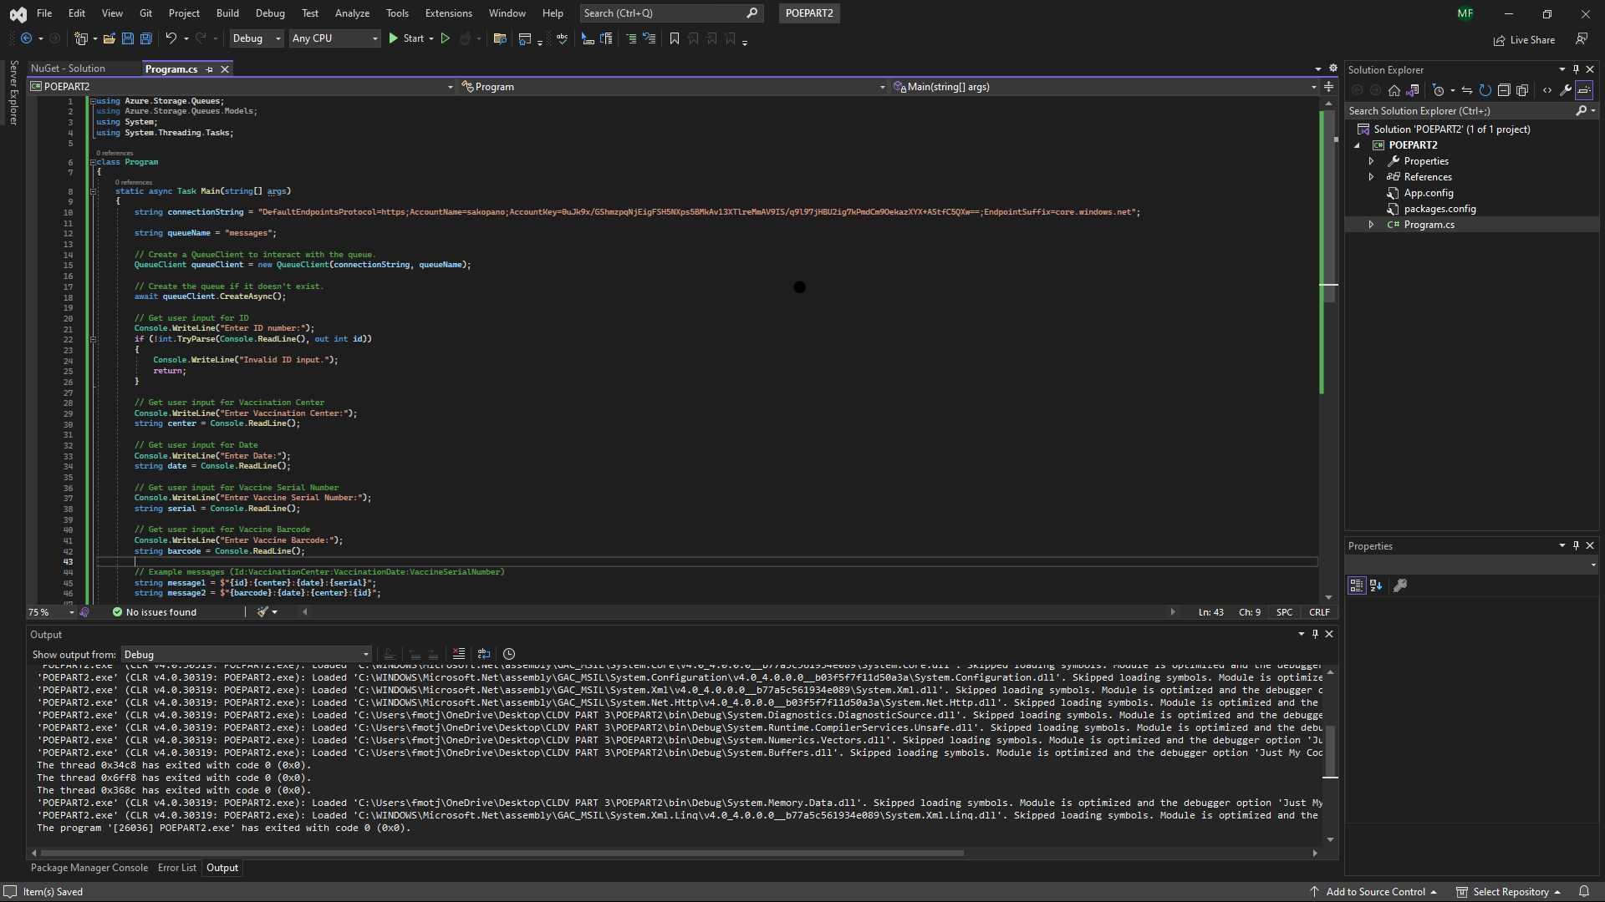

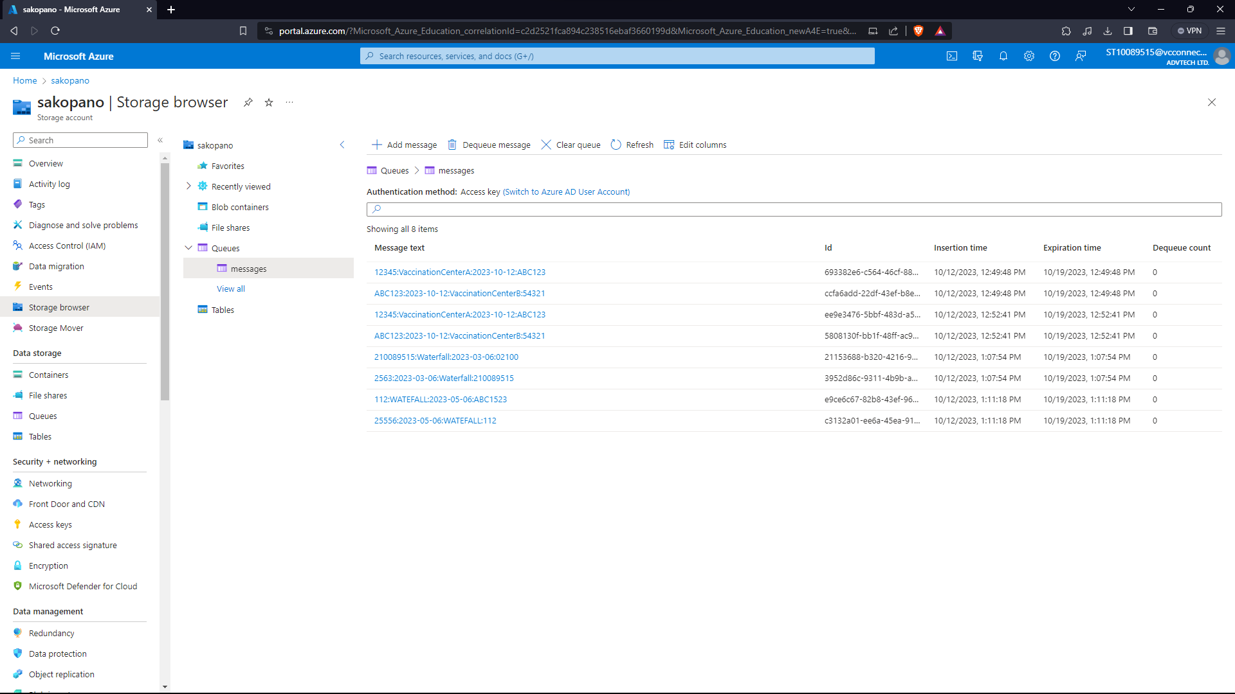

QUESTION B

FUNCTION CODE:

FIVE MESSAGE QUEUES IN AZURE:

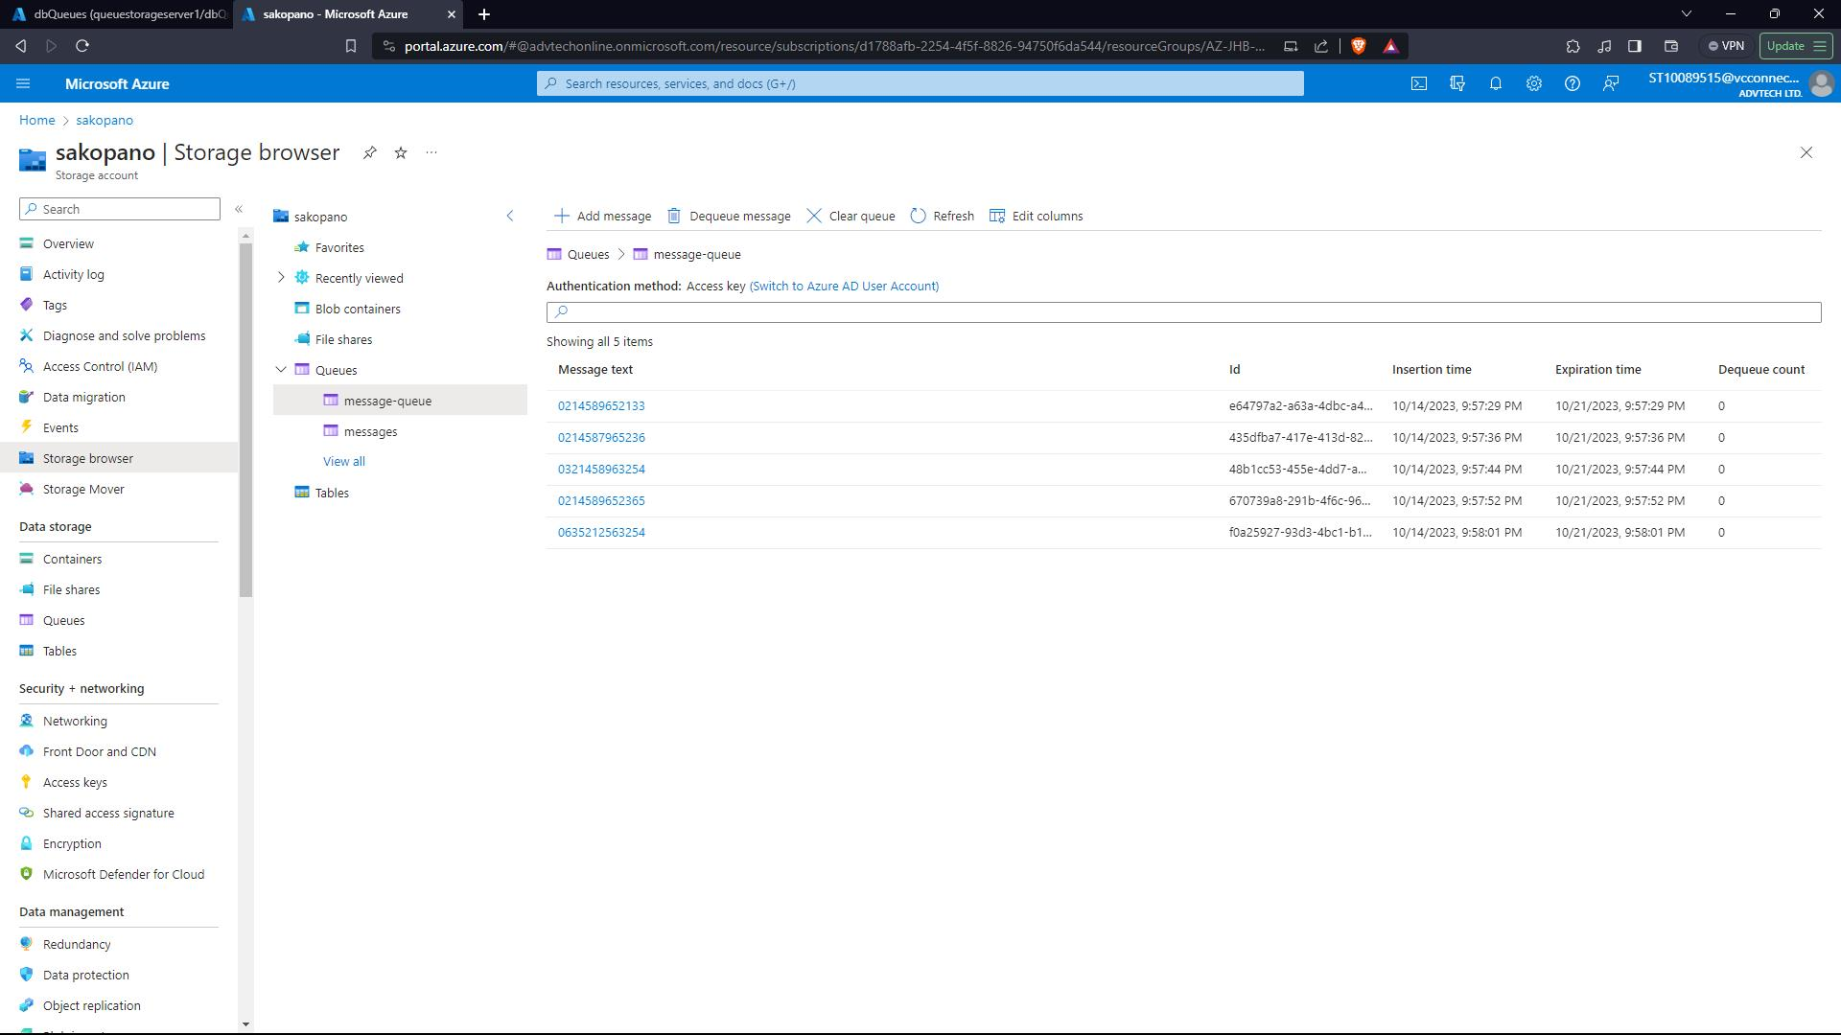

FIVE MESSAGE QUEUES IN AZURE SQL DATABASE:

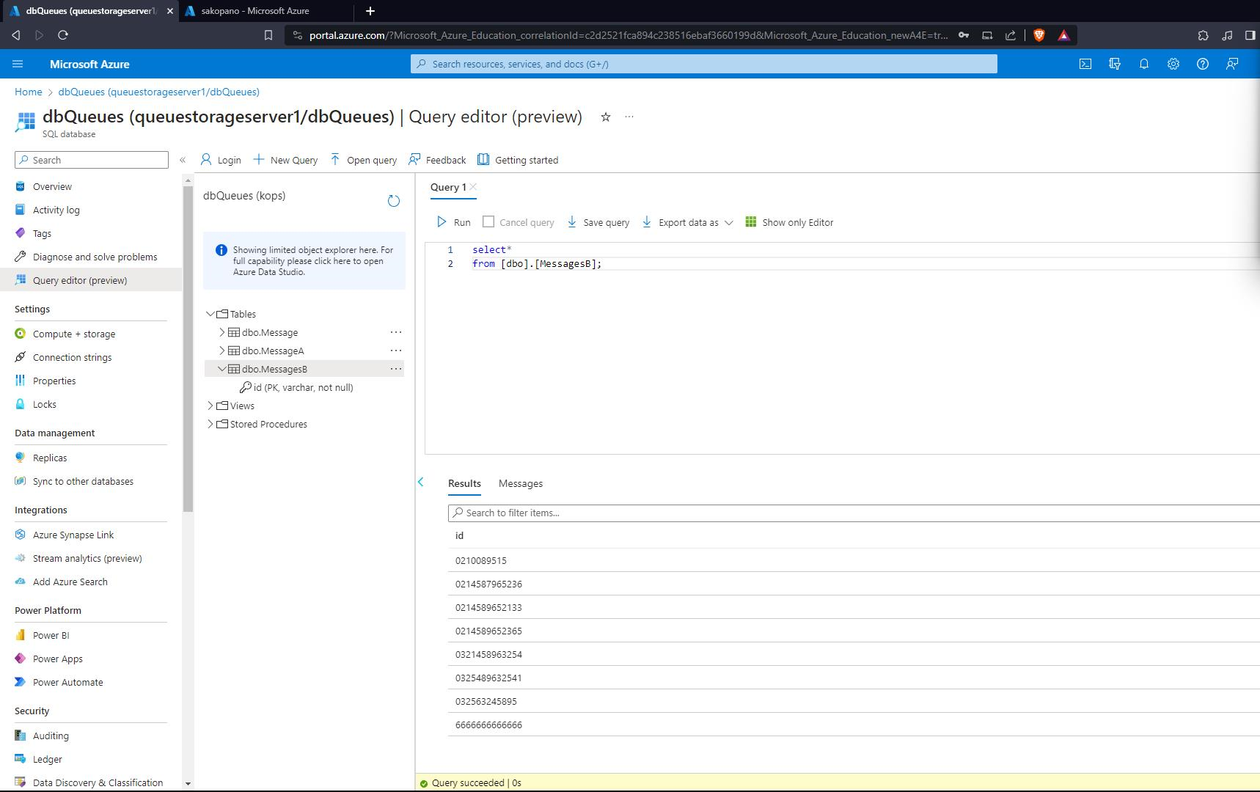

LINKS: <https://portal.azure.com/#@advtechonline.onmicrosoft.com/resource/subscriptions/d1788afb-2254-4f5f-8826-94750f6da544/resourceGroups/AZ-JHB-RSG-VCGPMD-ST10089515-TER/providers/Microsoft.Storage/storageAccounts/sakopano/storagebrowser>

<https://portal.azure.com/?Microsoft_Azure_Education_correlationId=c2d2521fca894c238516ebaf3660199d&Microsoft_Azure_Education_newA4E=true&Microsoft_Azure_Education_asoSubGuid=43ef35bb-adbb-42a3-8f83-be02d75aab29#@advtechonline.onmicrosoft.com/resource/subscriptions/d1788afb-2254-4f5f-8826-94750f6da544/resourceGroups/AZ-JHB-RSG-VCGPMD-ST10089515-TER/providers/Microsoft.Sql/servers/queuestorageserver1/databases/dbQueues/queryEditor>

<https://portal.azure.com/?Microsoft_Azure_Education_correlationId=c2d2521fca894c238516ebaf3660199d&Microsoft_Azure_Education_newA4E=true&Microsoft_Azure_Education_asoSubGuid=43ef35bb-adbb-42a3-8f83-be02d75aab29#home>